TERRAFORM -05
- Watch the Terraform-05 video.
- Execute the script shown in the video.
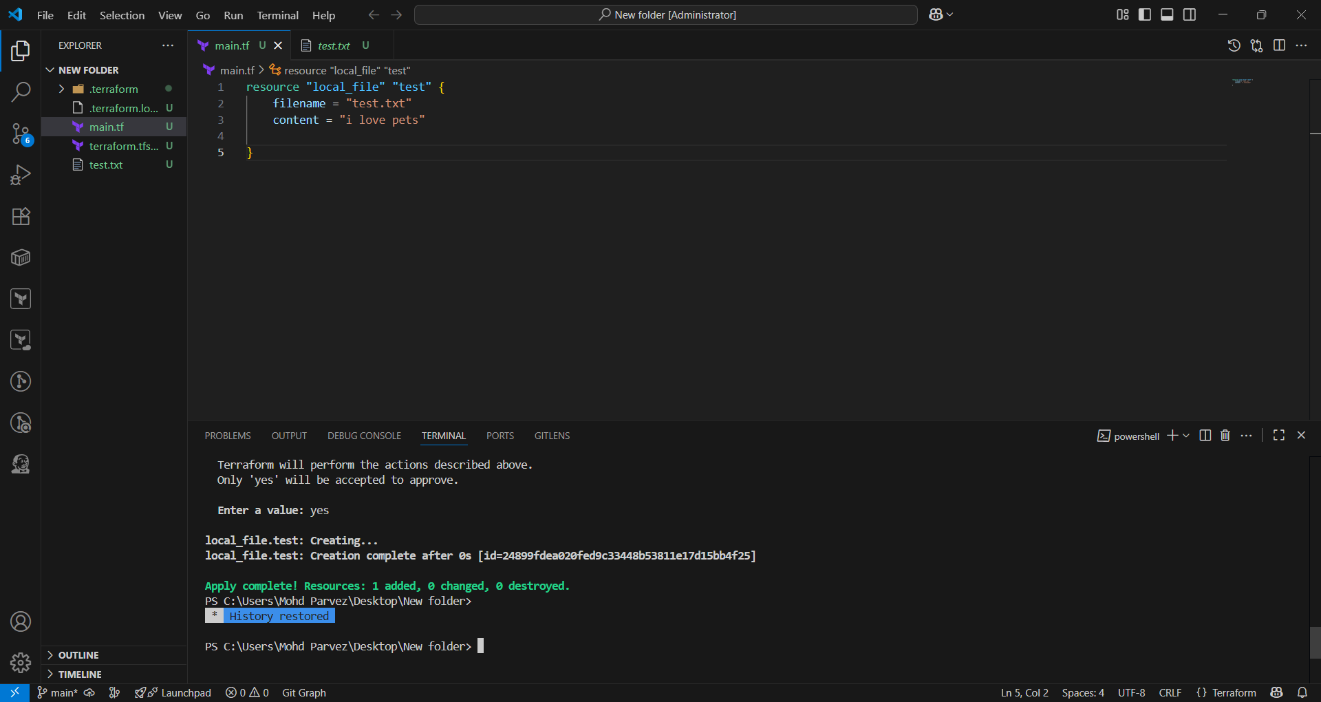
Aws configure give acees key and secret key to acess the aws account
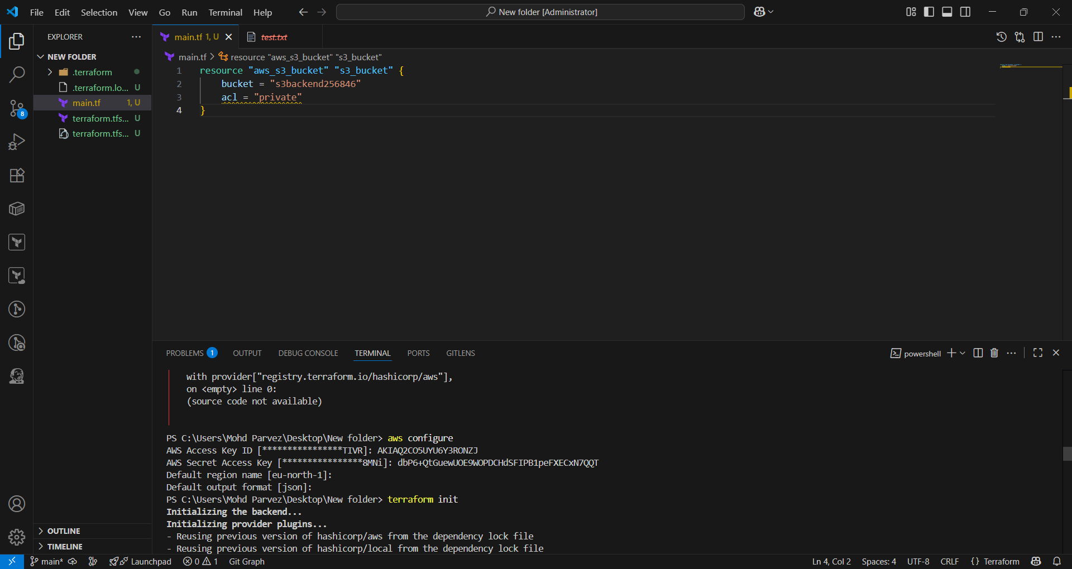

Giving s3 as backend for terraform.tf state file.
Giving this script.
terraform {
backend "s3" {
bucket = "s3backend2345678"
dynamodb_table = "terraform-state-lock-dynamo"
key = "terraform.tfstate"
region = "us-east-1"
}
}
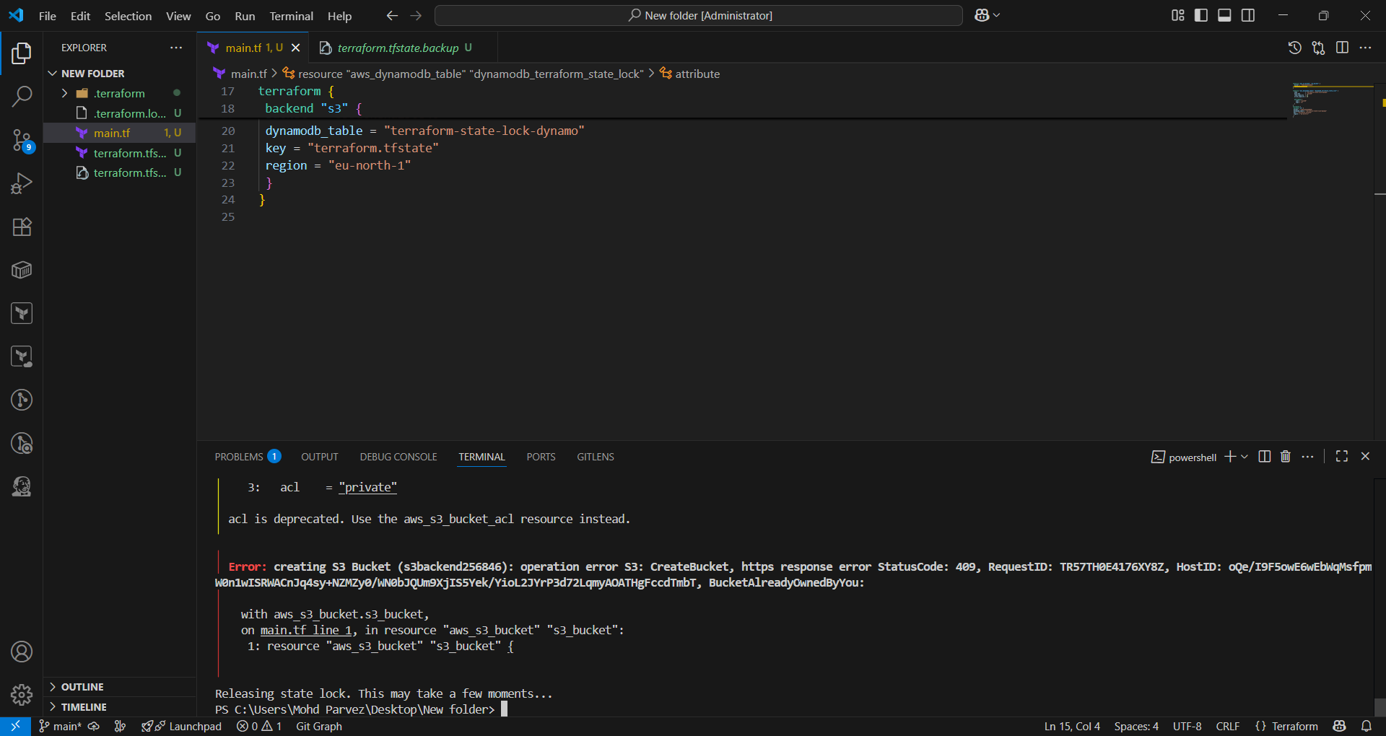
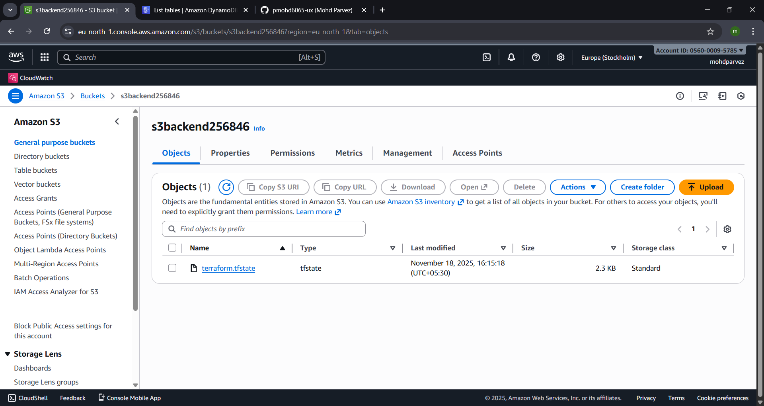

- Create one EC2 instance with httpd installed using a Terraform script.
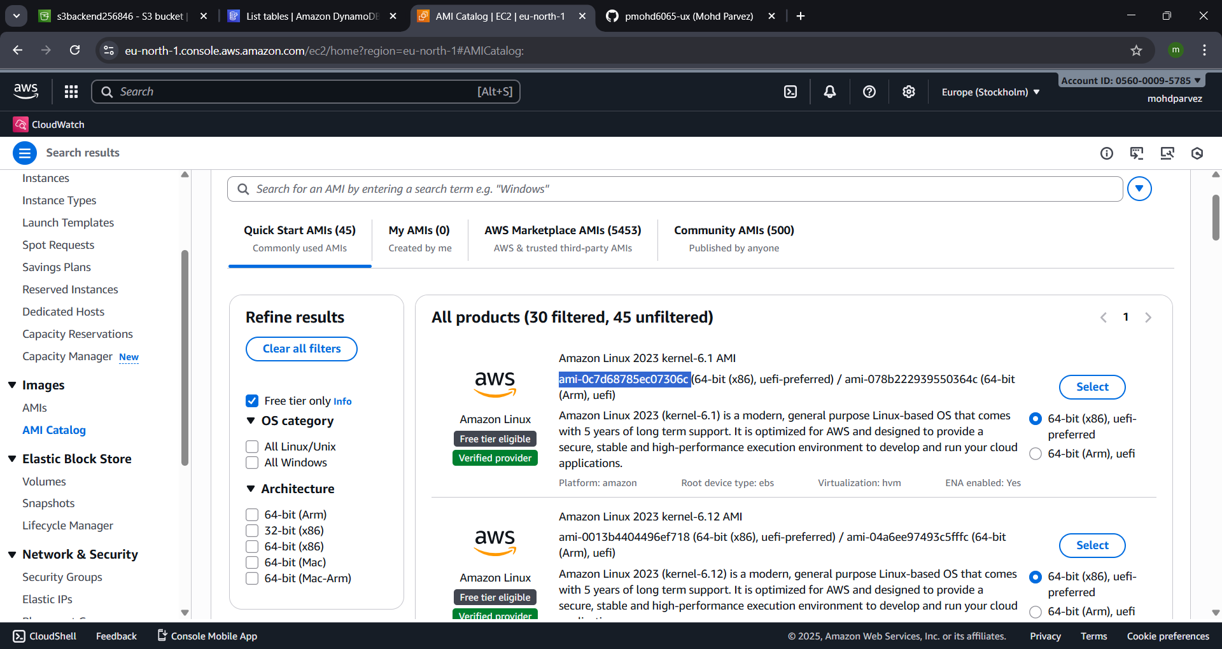
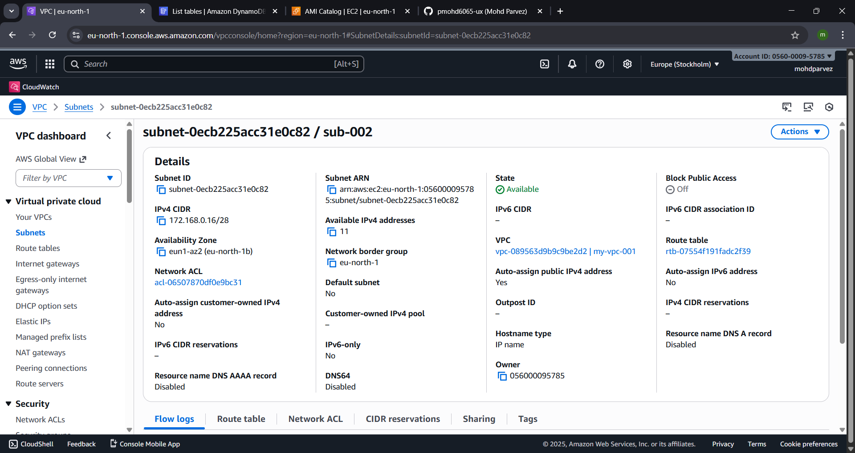
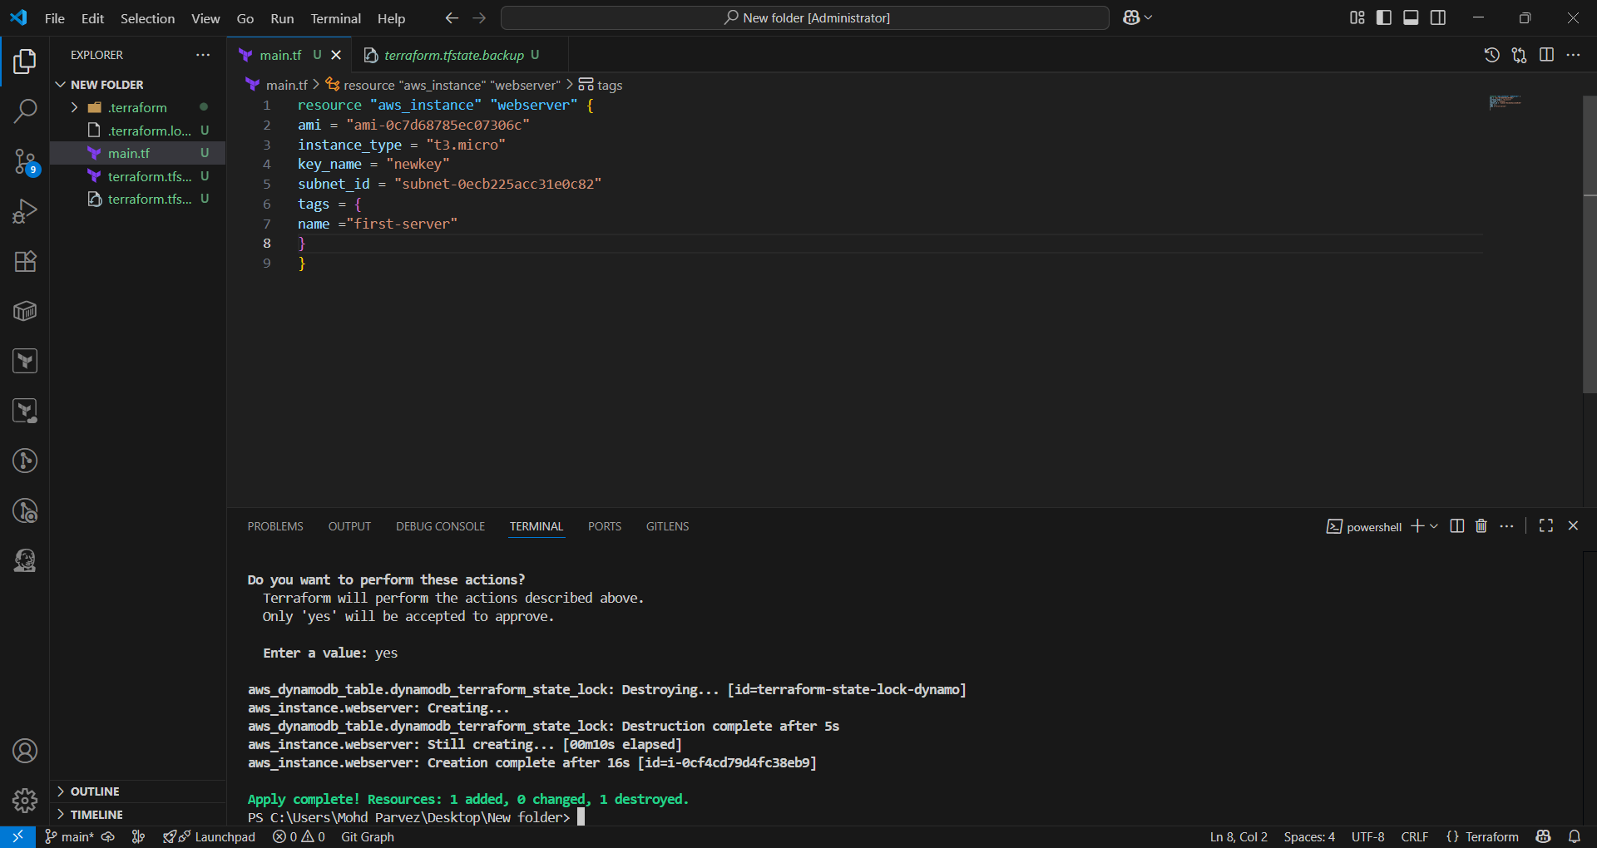
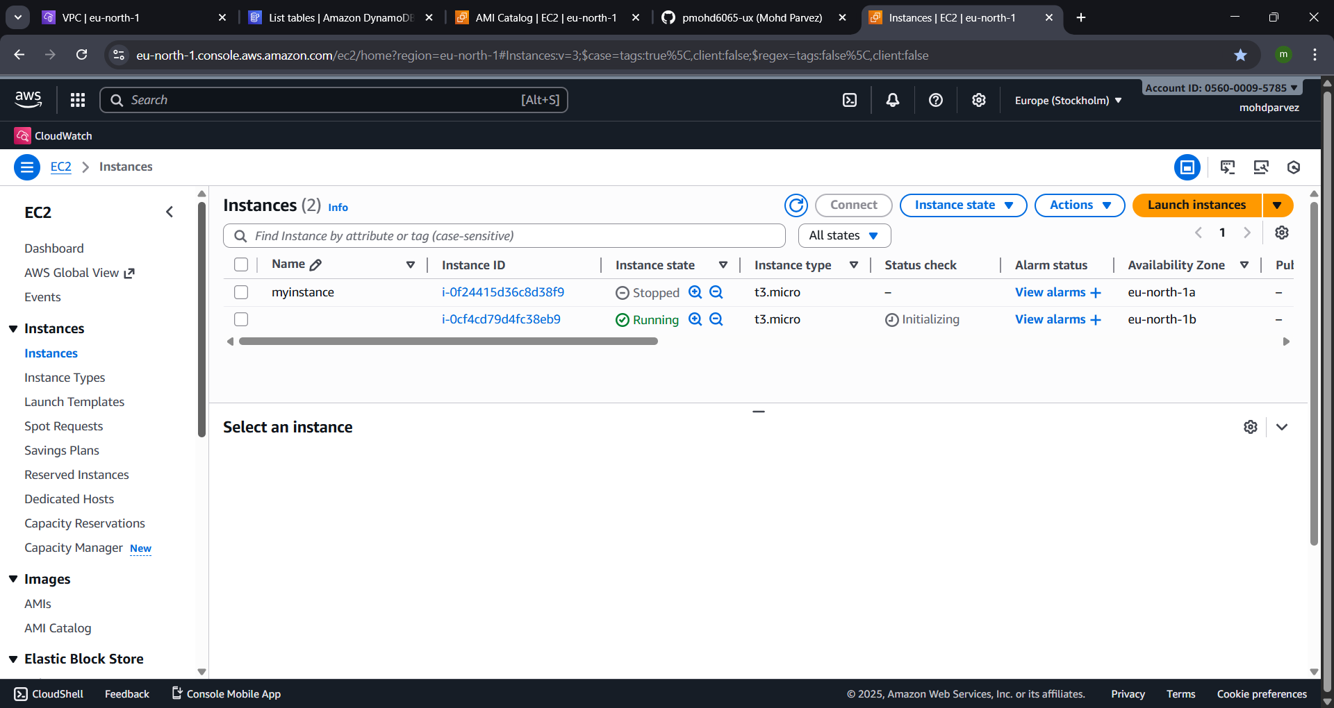

- Set up S3 as backend for task 3.
Aws creating s3 backend to store the .tfstate file to make it private
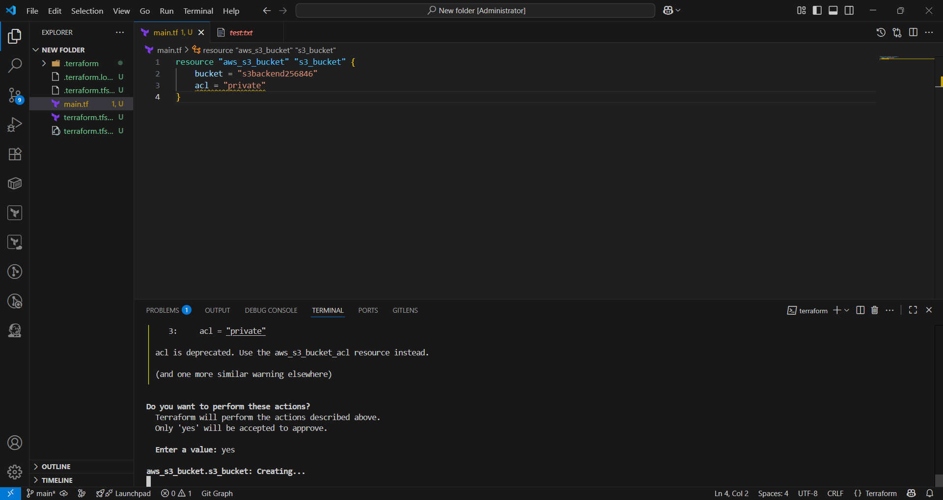
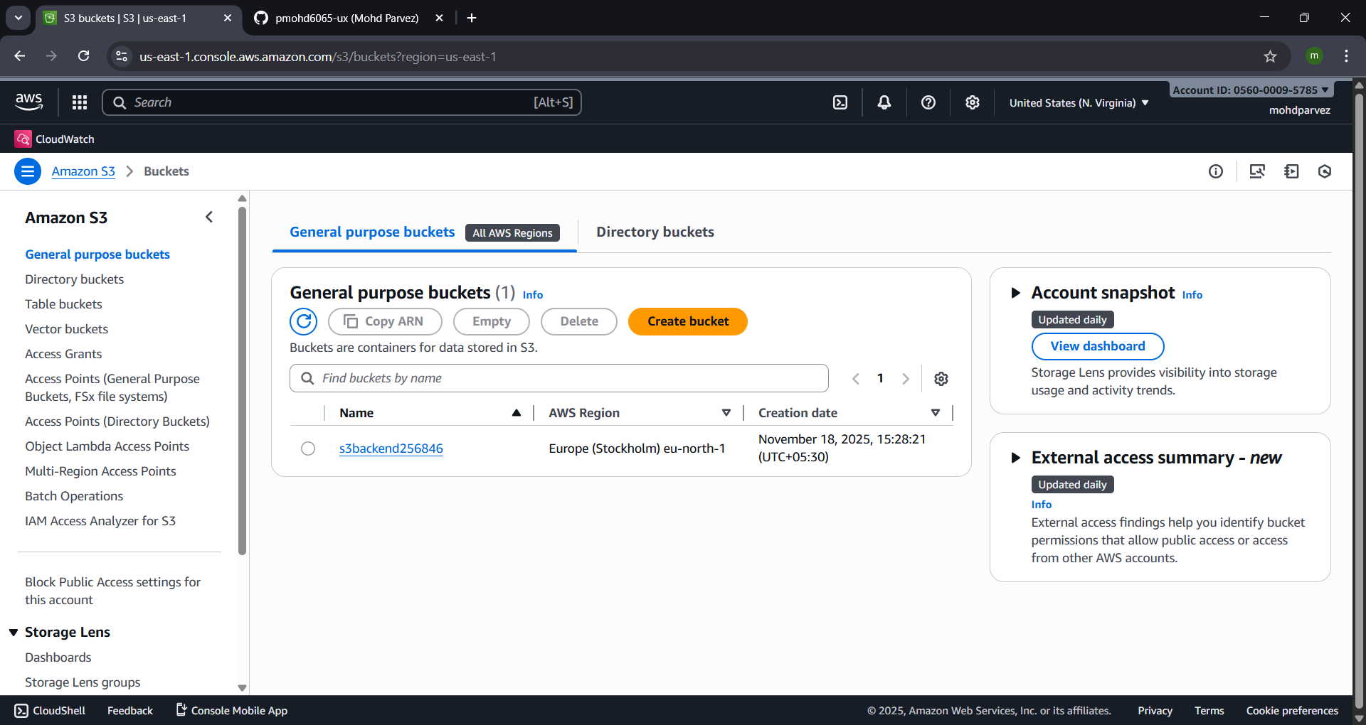

- Set up DynamoDB locking for task 3.
Create a dynamodb with this script
